Job Seekers
Information Booklet
(CALM 20)

SOURCES OF JOB INFORMATION
Employment and Immigration Canada
In Lethbridge: Service Canada Centre
Provincial Building
200 5th Avenue South, Lethbridge
1-800-622-6232
www.servicecanada.gc.ca

The federal government operates Canada Employment Centers across the country to assist workers to find jobs and to assist employers to find employees. Job seekers should register at their local Employment Centre. Lists of available local jobs are displayed there, along with lists of job openings across Canada.
When you go to an Employment Centre, a representative will give you a form to complete and then will ask some questions about your job preferences. Have a look at the job openings posted on the bulletin boards. If something suits you, the representative will give you the telephone number and/or address so that you can contact the employer. If nothing suitable is available, the representative will file your application and give you a call when something comes up.
Service Canada Centre for Youth (Part of Employment & Immigration Canada)
Formerly “Hire a Student”. Operates in the spring/summer months.
Phone: 403-308-4261

Provincial and Municipal Government Employment Services
Government is the largest employer in the country, and there are usually many jobs available.
Friends, Relatives, Neighbors, Acquaintances
Word of mouth is still one of the best ways to locate jobs. Let people know you’re looking for employment. They might know of job openings or can give you advice about who might be hiring. Obtain all the information you can and then follow it up. Remember to thank people for their help, particularly when you’ve been successful.
Former Employers
Depending on the reasons for your leaving, former employers might be glad to welcome you back.
Newspaper Help-Wanted Sections
It’s important to check the advertisements every day and to answer all appropriate advertisements. Be prompt, because many employers stop accepting applications once they have a reasonable number of suitable applicants.
Newspaper Business Section
If new businesses are open in your area or if a business is expanding, it’s often reported by the local media. These businesses might be hiring new employees.
Group Job Search Programs
You might be interested in participating in a job search program if one is available in your community. Trained personnel assist participants in organizing their job search. Moral support from group leaders and fellow participants has helped many participants to succeed in finding employment.
Private Employment Agencies
Employers pay these agencies to locate and screen prospective employees. You register with the agency, usually complete tests that indicate your skills, and are then contacted if an appropriate job opening is available. For best results, you should be able to specify the type of job you want. Be ready to go for interviews on short notice. Some agencies also charge job applicants a fee, so be sure to check this out.
Some of these agencies are commissioned by companies to locate and screen both skilled and semi-skilled temporary workers. Working as a temporary or part-time employee could provide a source of income while you look for a full-time job. You would also be gaining experience and using your job skills.
Help Wanted Notices Posted in Public Buildings
Study public bulletin boards carefully.
Plants and Factories in Industrial Areas
In one day, you could canvass a dozen or more prospective employers.
Construction Sites
Job-opening notices are sometimes posted at building sites.
New Office Buildings, Shopping Centres, and Factories
Workers are usually needed, including security guards, word processors, clerks, secretaries, computer personnel, and sometimes managers. Three or four suitable jobs might be available in one new office building alone.
Yellow Pages of the Telephone Book
Prospective employers can be found by looking in the Yellow Pages under various services and products related to the field in which you want to work.
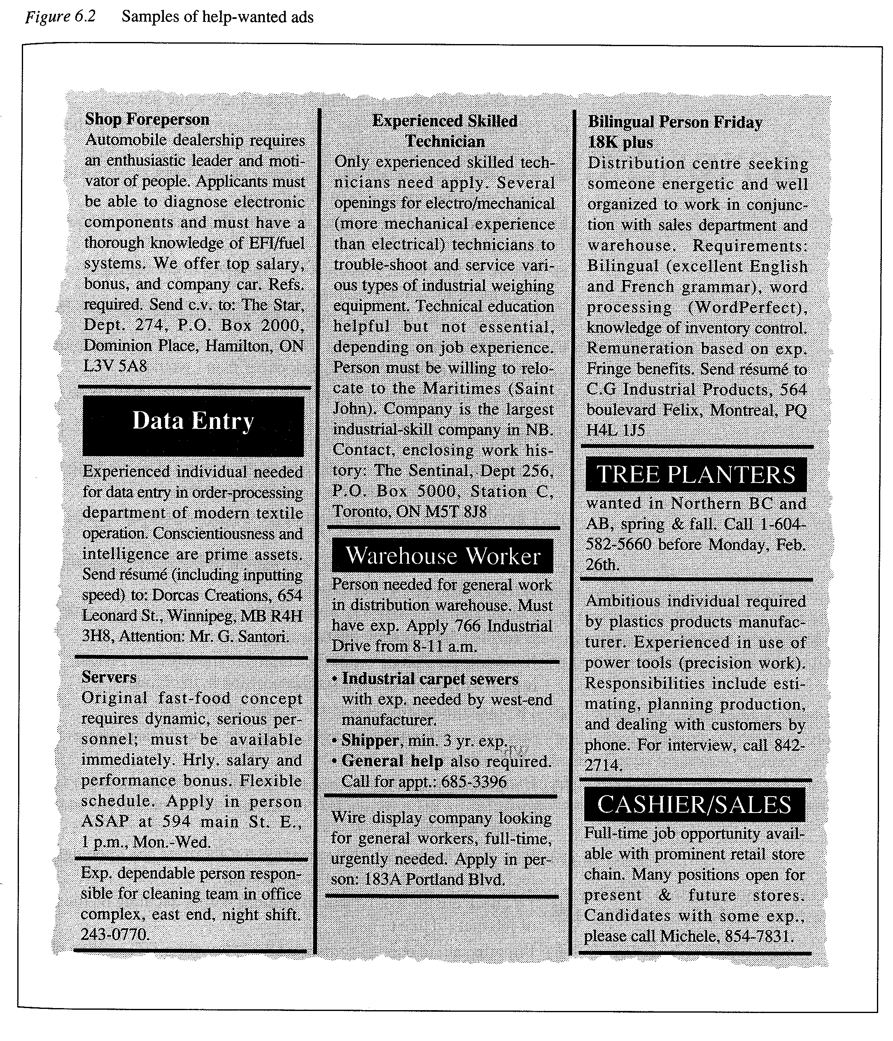
ANALYSING JOB ADVERTISEMENTS
Answer the following questions about the job advertisements in Figure 6.2
- Which job offers would you respond to with a letter?
- Which job requires the use of more than one language?
- Which jobs would definitely require working nights? Which jobs would probably require working nights?
- Which jobs do you think would require heavy physical work?
- Which job ad asks for the most education?
- Which jobs do you think would require computer experience?
- Which jobs require a resume?
- Which job ads don’t ask for experience?
- If all of the jobs were in your region, which jobs would you apply for?

EXERCISE: Extracting Information from Job Advertisements
Consult one of your local newspapers to find an advertisement for a job that fits in each of the following categories. Write the name of each category in your notebook and then use the information in the advertisement to answer the questions that follow the list of categories.
- Office and sales (secretary, administrative assistant, clerk, computer operator, salesclerk, sales representative).
- Mechanical and Industrial Service (mechanic, shop foreman, engineer)
- Medical and Food Services (nurse, nursing assistant, doctor, X-ray or lab personnel, cashier, server)
- Personal Services (counsellor, lawyer, teacher)
- What is the job title?
- What qualifications does the job require?
- Whom are you supposed to contact regarding the job?
- How are you supposed to contact the prospective employer (in person, by telephone, by letter, etc?)
PREPARING FOR THE JOB SEARCH
Effective preparation for your job search involves gathering together the items and information that you’ll need. If you’re well prepared, you’ll save time and be ready to take advantage of opportunities that the unprepared could miss. The following are some important preparations that you must make.
- Social Insurance Number (SIN): You must have a SIN. This number officially registers you with the federal government and is required by all employers. To obtain a Social Insurance Number, go to your local Employment and Immigration Canada office and ask for a form to complete. After you have sent in the form, you should receive a card within six weeks.
- Identify what type of job you are looking for.
- Personal Information: You need to gather all of the appropriate personal information that an employer might need: resume, copies of certificates and diplomas, etc.
- Obtain references: Contact people whose names you might want to use as references. These are people whom the employer could contact to vouch for your character and ability. Naturally, you want references who will speak favorably of you. Prepare a record of their names, titles, full addresses (including postal codes) and telephone numbers and email addresses.
- Appearance: You need to be well groomed and have appropriate clothes to wear to meet prospective employers. Remember, you are the product, so package yourself appropriately. Do you need to buy some suitable clothes? Do you need a haircut?
- Maintain Records: You need to maintain records of contacts you make with prospective employers, so that you can take appropriate follow-up action.
- Job Search Techniques: You must know where and how to look for a job.
- Positive Attitude: You need to maintain a positive attitude.
Collecting Personal Information
To be well prepared for your job search, you should gather together all of your personal information. You can use this information in preparing your resume, completing application forms, and answering questions during interviews. The best way to collect this information is to write everything down on a personal information form, using the following guidelines:
- Full Name, including any middle names.
- Date and place of birth
- Address, including apartment number (if applicable) and the postal code.
- Marital status (Are you married or single?)
- Social Insurance Number
- Telephone Number (all numbers, home, cell, work – including area code)
- Driver’s license number
- Three references: List the names of three people who know your skills and what type of person you are. They can be previous teachers or employers. Record their full names, job names or titles, addresses, and telephone numbers. Make sure you have permission to use their names.
- Past employment: Where have you worked before? How long did you work there (start and end dates)? Who was your supervisor? What type of work did you do?
- Education: List the schools you have attended, but only as far back as high school.

JOB INTERVIEWS
PREPARING FOR AN INTERVIEW
When you are granted an interview, you have only one chance to make the best possible impression. Five basic rules will help you do this:
- Be clean and neat. The interview’s first impression will be based on your appearance. You and your clothing should be clean and neat, and your clothing should be appropriate for the position for which you are applying. Use perfume or aftershave sparingly or not at all, and be moderate in applying make-up. Hair should be clean, combed properly and styled appropriately, and beards, mustaches, and fingernails should be clean and trimmed.
- Know where you’re going. Unless you’re already familiar with where the company is located, check beforehand to find out how to get there. Then determine the appropriate type of transportation and how long the trip will take. Being late for an interview is guaranteed to make a bad impression. If you have time, it would be smart to actually make a trial run to ensure that your understanding of the location and your estimate of the time necessary to reach it are correct. In any case, allow yourself at least five minutes more than your estimate. If circumstances beyond your control occur (bus breakdown, etc), find a telephone if at all possible and let the interviewer know what has happened. Be sure, too, that you ask where you are to report when you actually arrive at the building. Then, when you arrive, tell the receptionist your name and that of the person with whom you have the appointment. If you have to wait, do so with a minimum of fidgeting.
- Have a positive attitude. You’re not going to get every job you apply for, but this doesn’t mean that you’re a failure. Usually it mean s that the job just wasn’t right for you and that perhaps the next job interview will result in the job you want. So, approach each interview positively and enthusiastically. Even if it doesn’t result in a job offer, the interview experience will mean that you are even better prepared next time.
- Know something about the company. Find out basic information about the employer and the position you are applying for before the interview. What does the company do? Is it well established in the area? Sources of this information could include company literature (brochures, advertisements), friends in the area, the local Chamber of Commerce or Board of Trade, municipal records, other employees with whom you are acquainted, etc.
- Bring necessary paperwork. Have with you additional copies of your resume, originals and copies of reference letters and school records, and samples of your work if you are applying for the type of job that might require these, such as drafting, art, design, etc. Also, bring a copy of your list of references, complete with addresses and telephone numbers. These are often asked for at interviews.
JOB INTERVIEW DO’S AND DON’TS

Interview DO’S
- Dress appropriately and be well groomed.
- Make sure that your credentials are up to date.
- Have extra copies of necessary documents (resumes, reference list, and reference letters).
- Let the interviewer take the lead in the conversation.
- Show respect for the interviewer.
- Exhibit poise and self-control.
- Try to overcome nervousness.
- Act naturally. Maintain eye contact.
- Be pleasant and friendly. If a hand is offered, give a firm handshake.
- Listen very carefully.
- Answer questions clearly and fully. Avoid one-word answers.
- Answer all questions honestly.
- Make yourself understood.
- Stress your qualifications for the job and your interest in it.
- Speak in terms of specific jobs, rather than saying, “I’ll take anything”.
- Be realistic when discussing wages.
- Ask sensible questions.
- Thank the interviewer for his or her time as you leave, holding out your hand for a handshake.
- Make notes after the interview so you will remember details of the discussion.
- Send a thank-you note after the interview.
Interview DON’T S
- Bring other people to the interview.
- Be late.
- Smoke (decline if invited to smoke).
- Chew gum.
- Interrupt the interviewer while she or he is talking.
- Criticize former employers.
- Make salary the main theme.
- Mention personal, domestic, or financial problems.
- Freeze or become tense.
- Become emotional.
- Become impatient.
- Limit your time for the interview.
- Use negative body language.
- Prolong the interview.
- Suggest how the employer should run his or her business.
- Be overconfident.
- Talk too much.
- Feel that the world owes you a living.
- Display a feeling of inferiority. For example, don’t sound unsure of yourself by making statements in a questioning tone of voice.
INTERVIEW DAY CHECKLIST …
Use the checklist below on the day of your interview.
- I have prepared a list of appropriate questions to ask the interviewer.
- I have my list of references ready should it be requested.
- I have reviewed my benefit statements and am prepared to sell myself to get the job.
- I have done the necessary research on the company with which I’m interviewing.
- My hair is cut, washed, combed, and styled in a professional manner.
- I have bathed and used deodorant.
- My makeup, jewelry, and perfume or after-shave lotion are not excessive.
- My fingernails are trimmed, clean and if polished, have been freshly done.
- My teeth are clean, and have used a mouthwash for fresh breath.
- My shoes are clean, neat and unscuffed.
- My clothes are clean, pressed and styled appropriately for the job for which I’m interviewing. I feel comfortable in them.
- I promise myself that I will not fuss with or rearrange my clothing, hair, etc. once I arrive.
- I promise that I will be myself whatever the circumstances of the interview.
- I will take extra copies of resumes, transcripts, and portfolios with me in case they ask for these.
- I have all the necessary tools to correctly and neatly complete the application form should I be asked to fill one out.
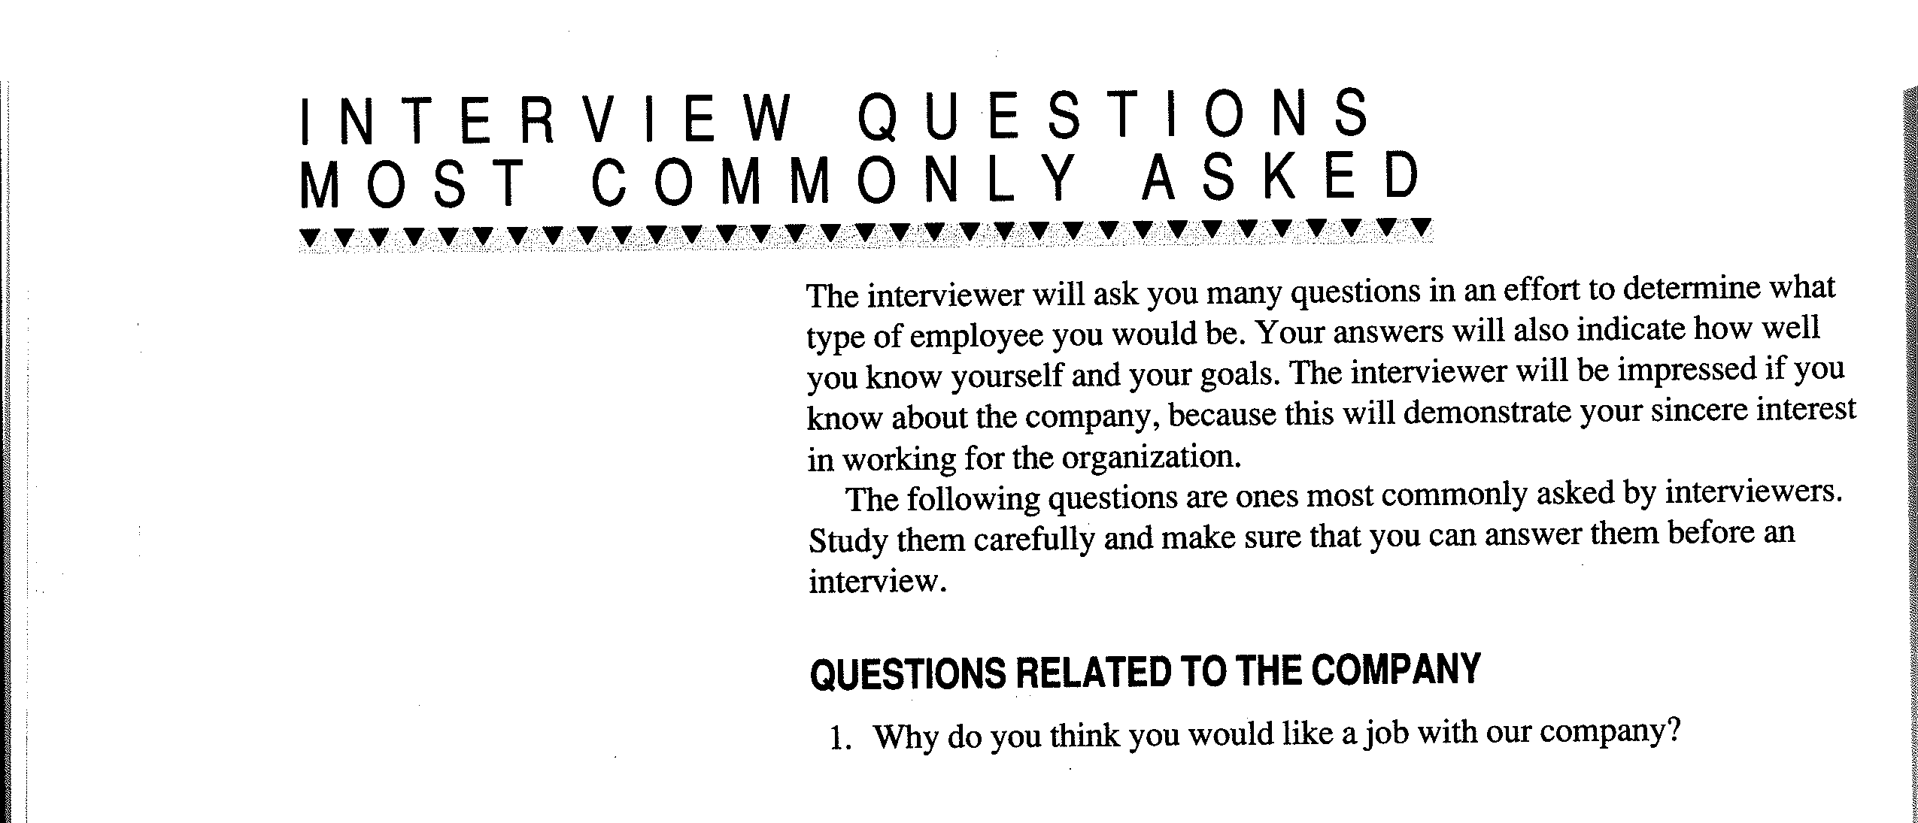

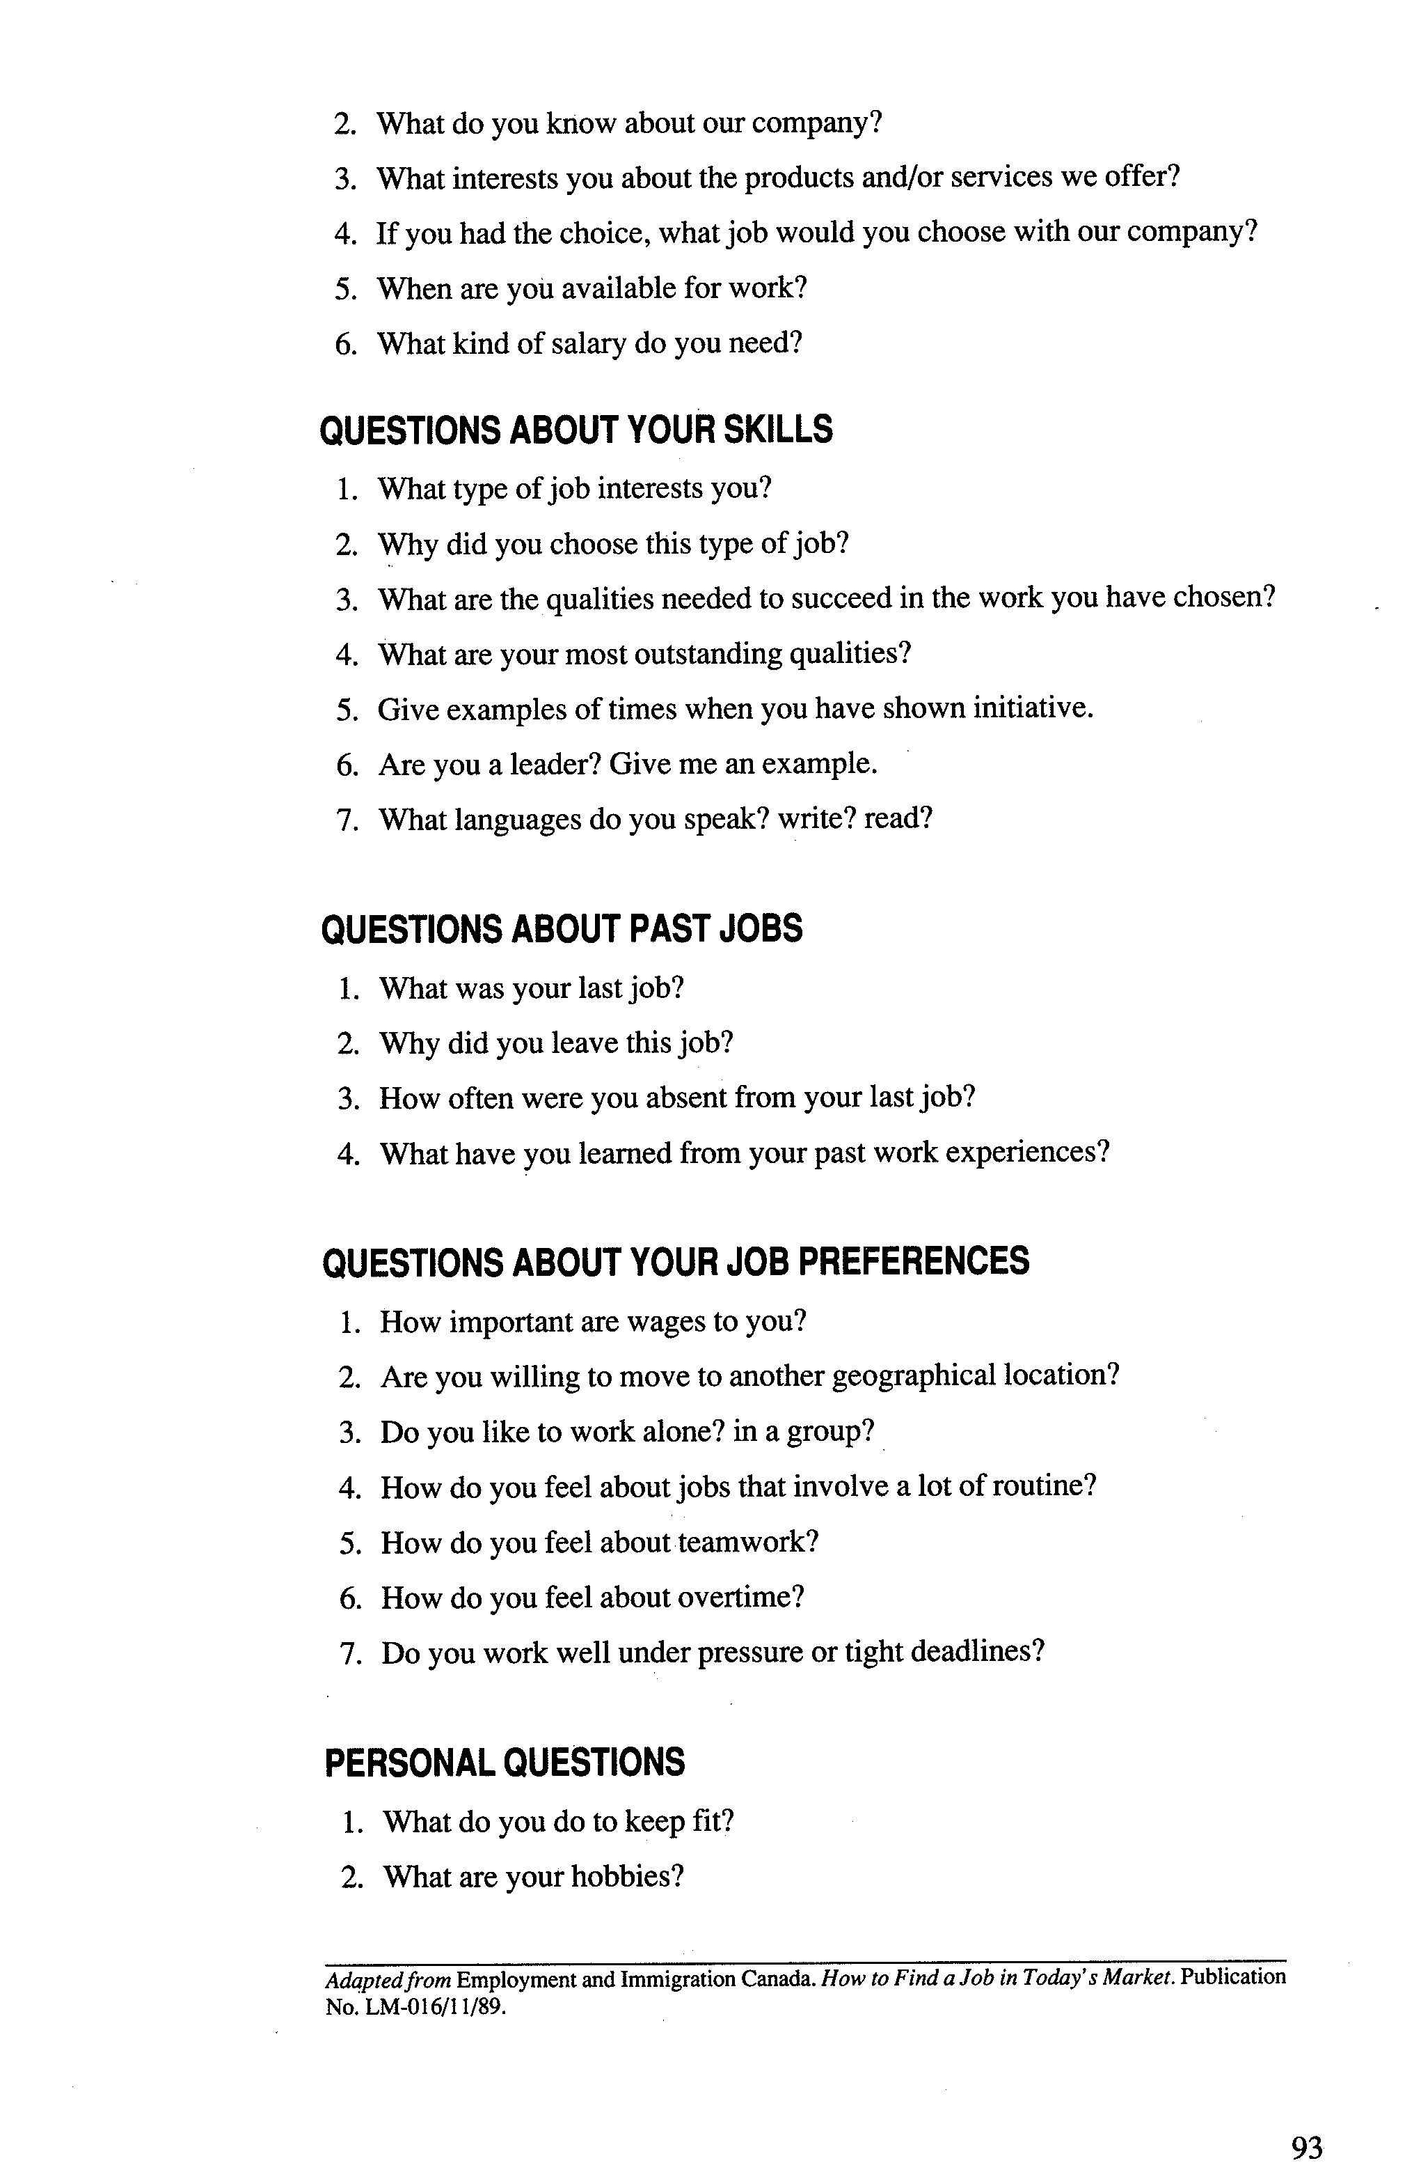
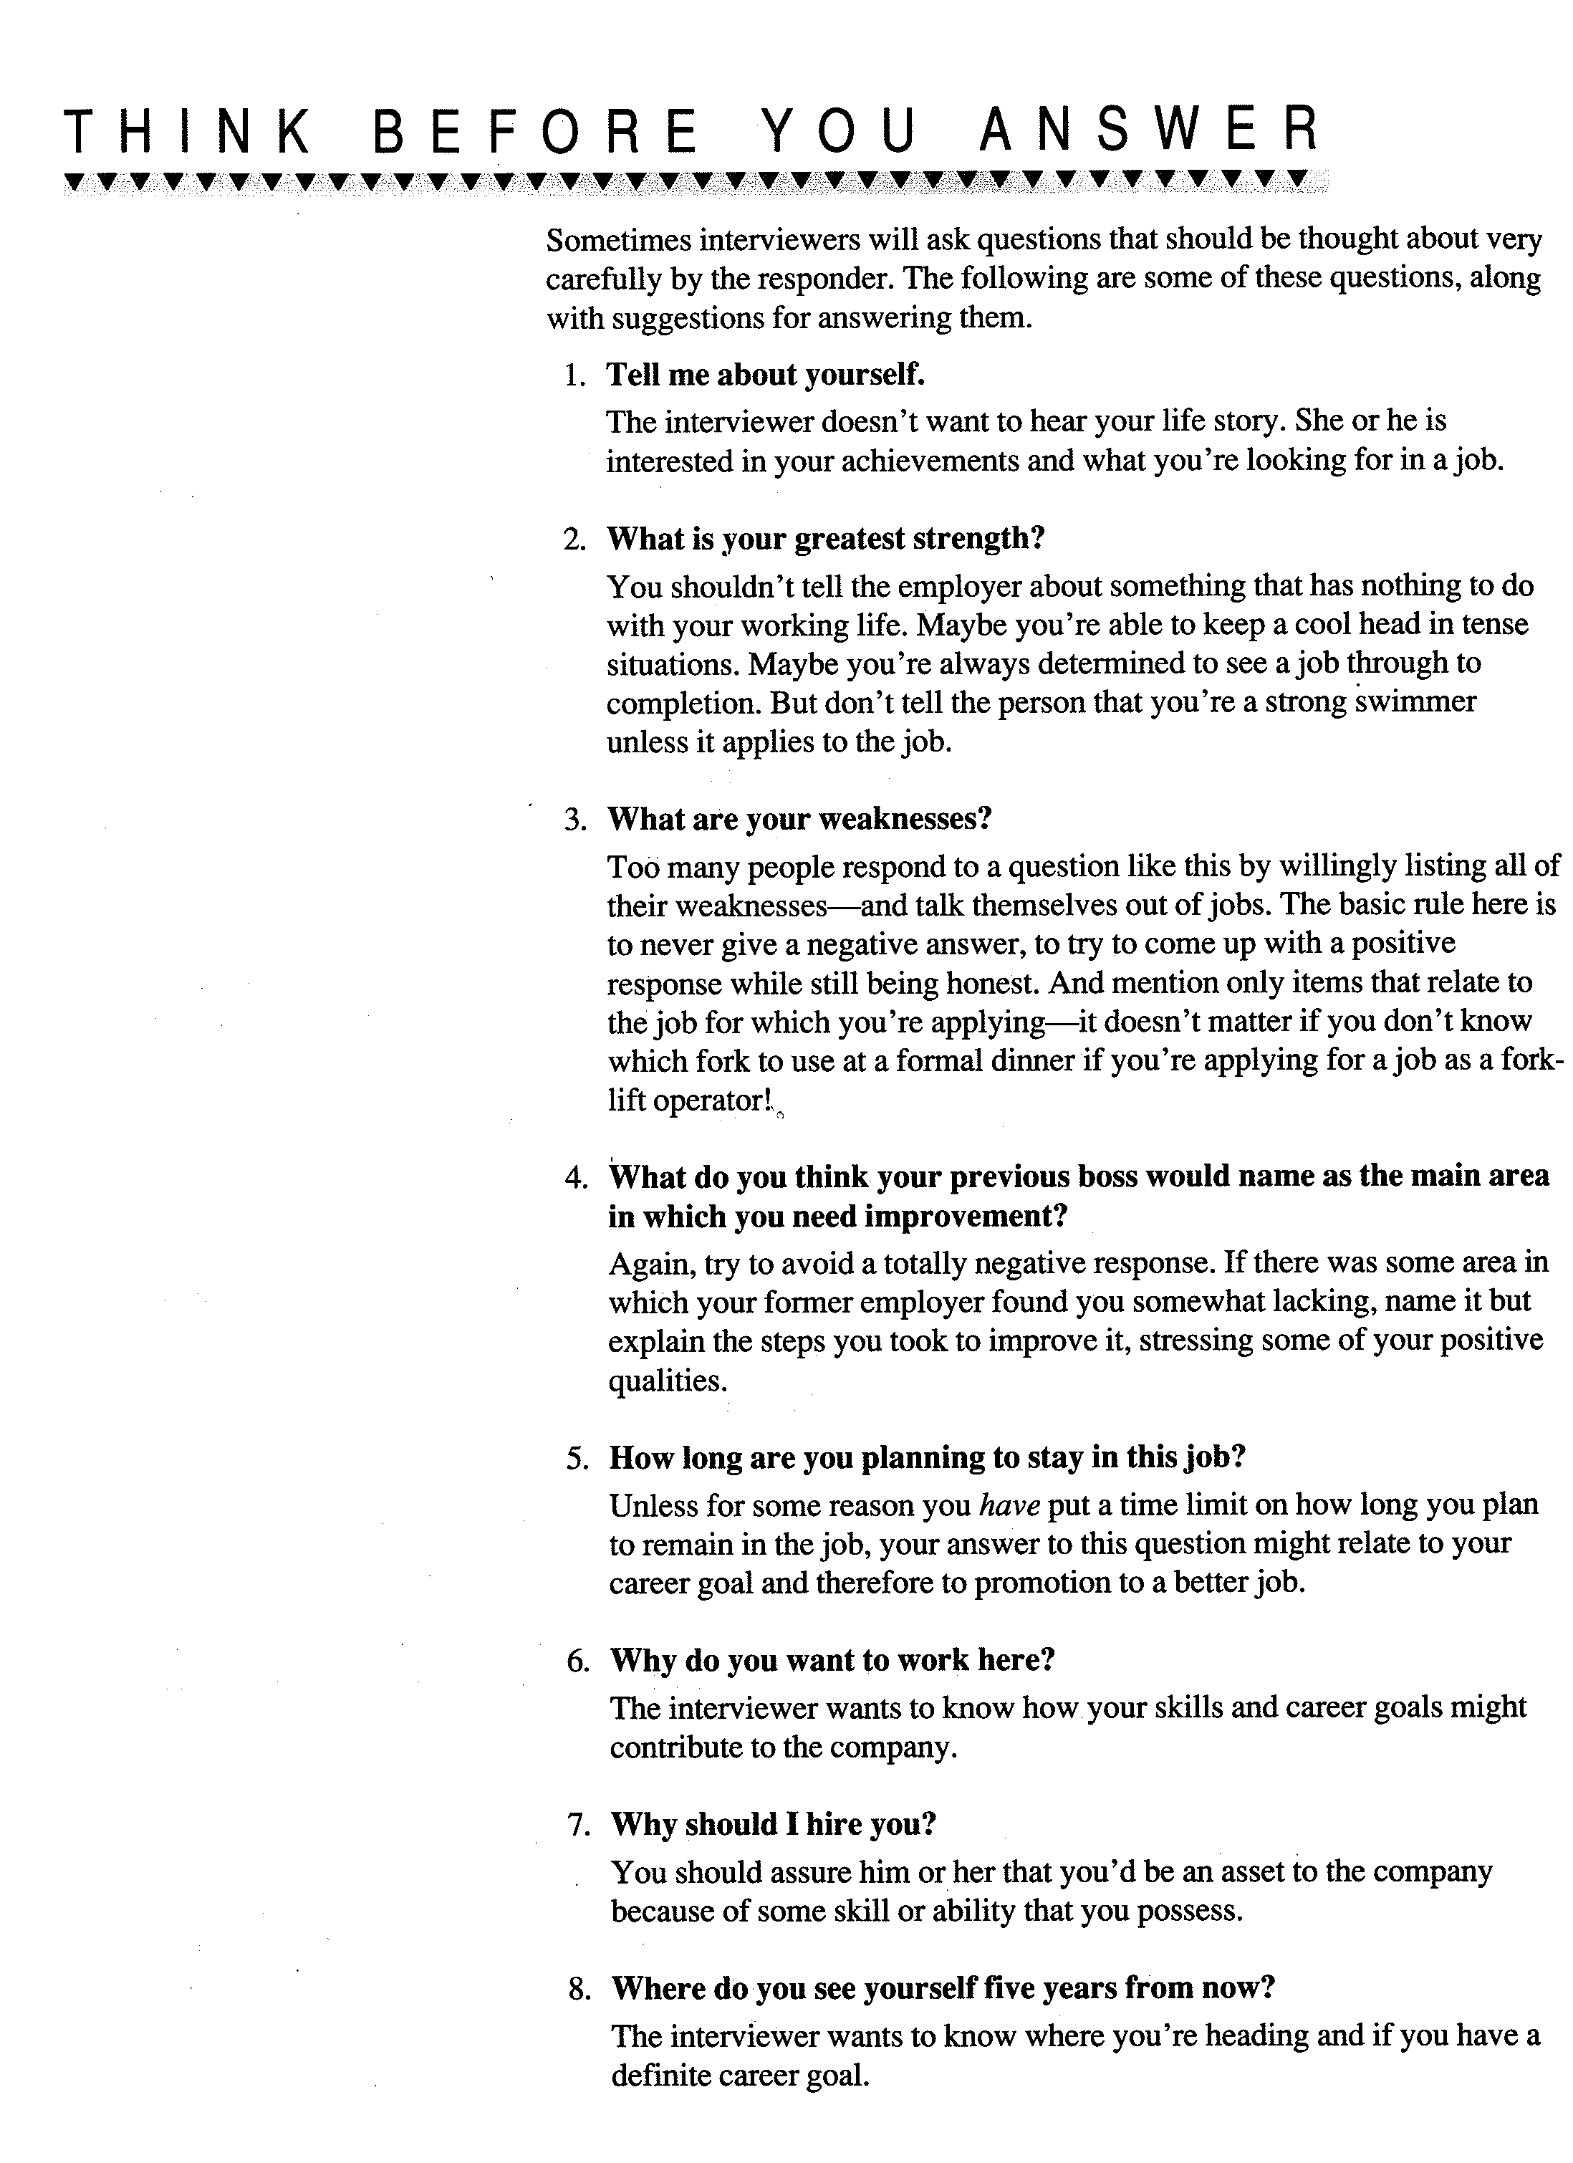
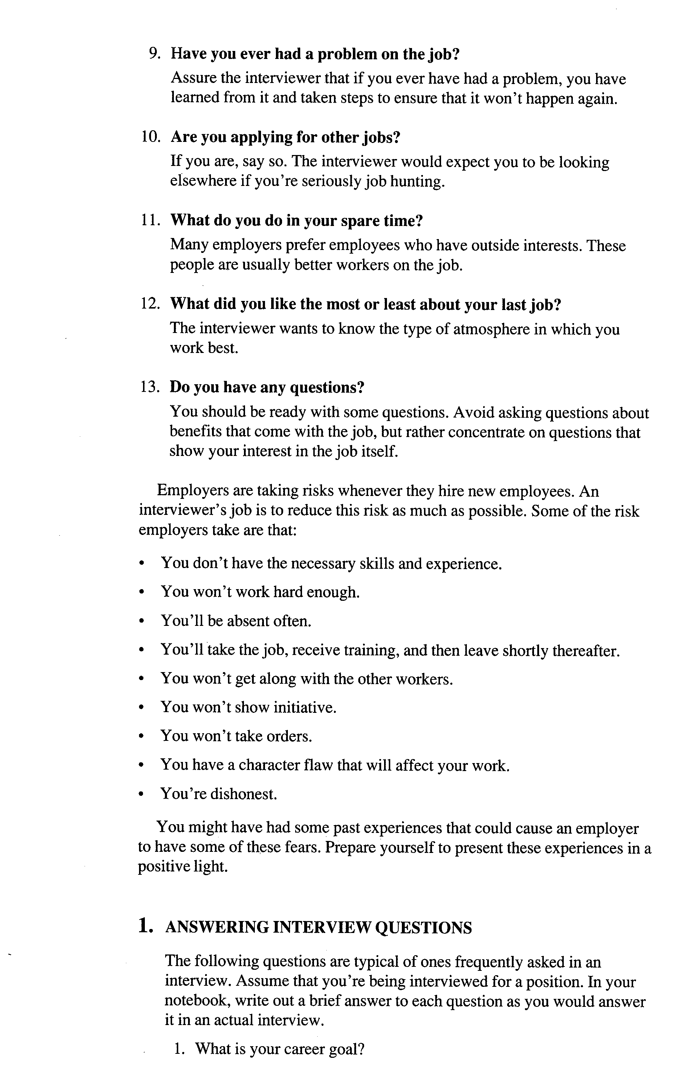
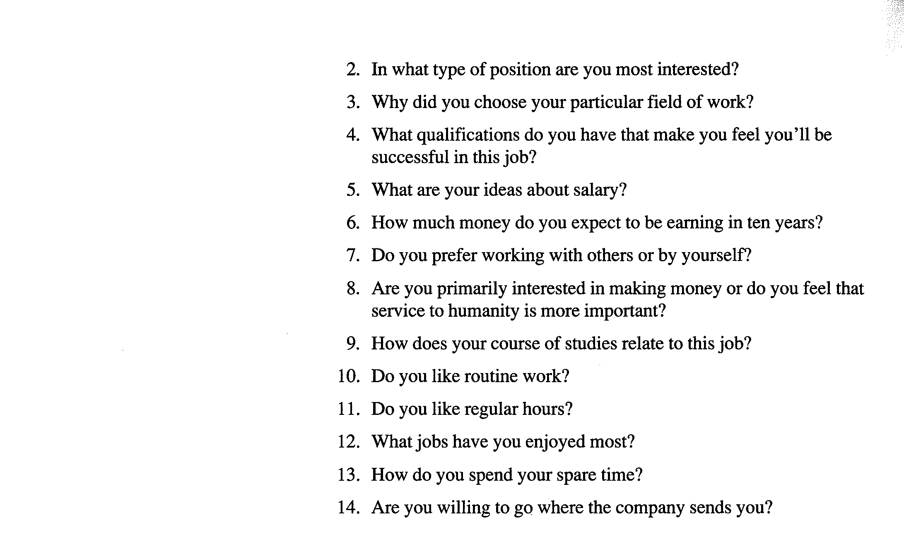
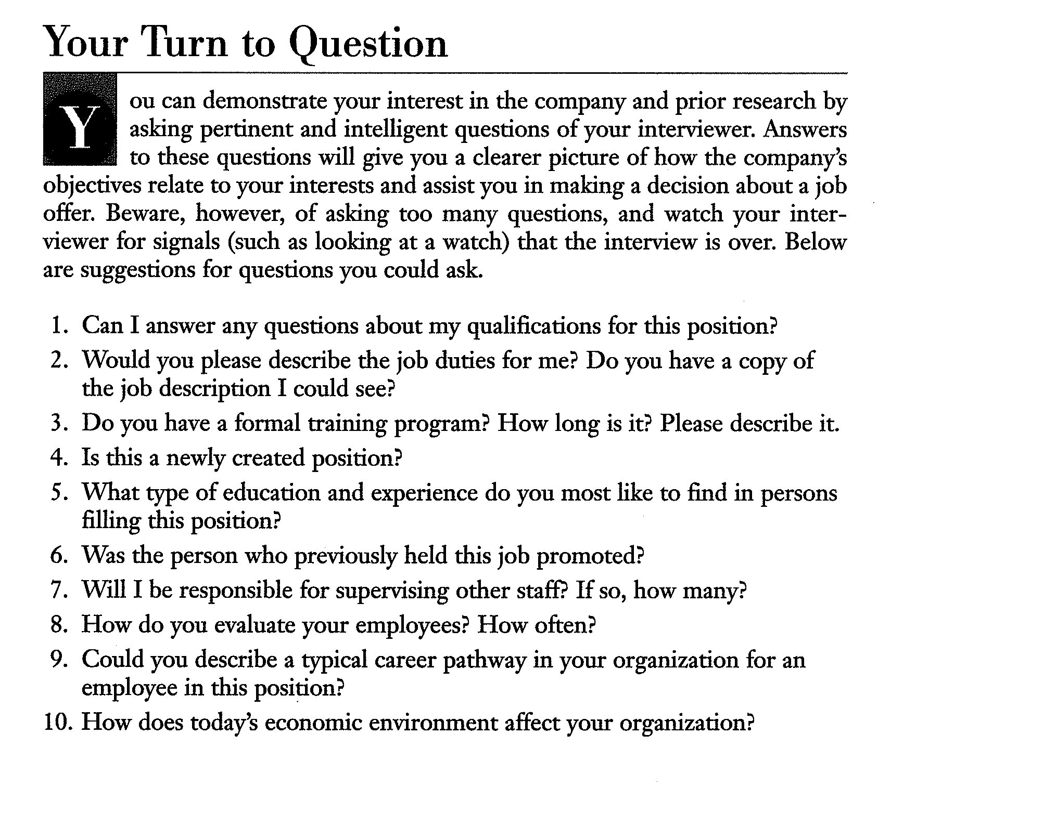
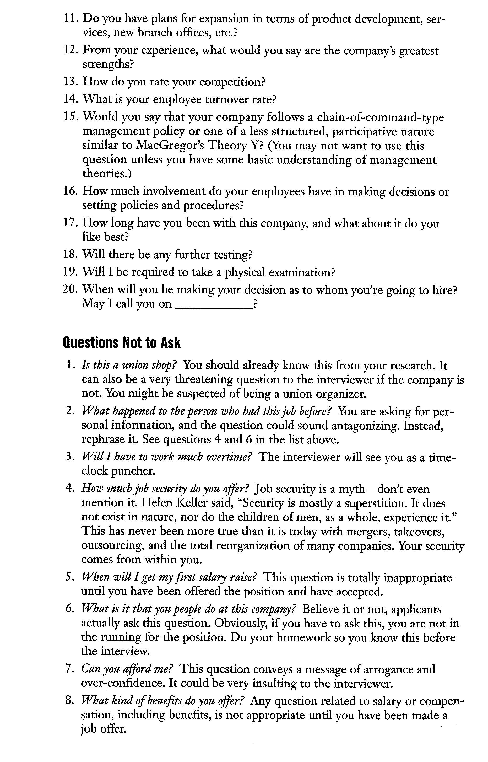
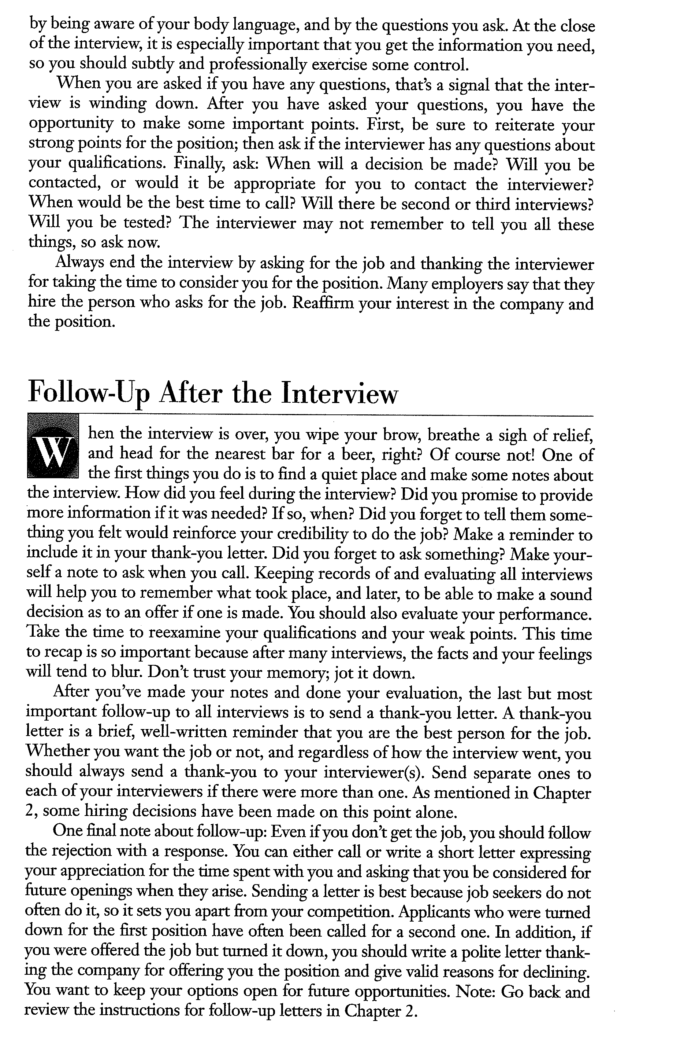
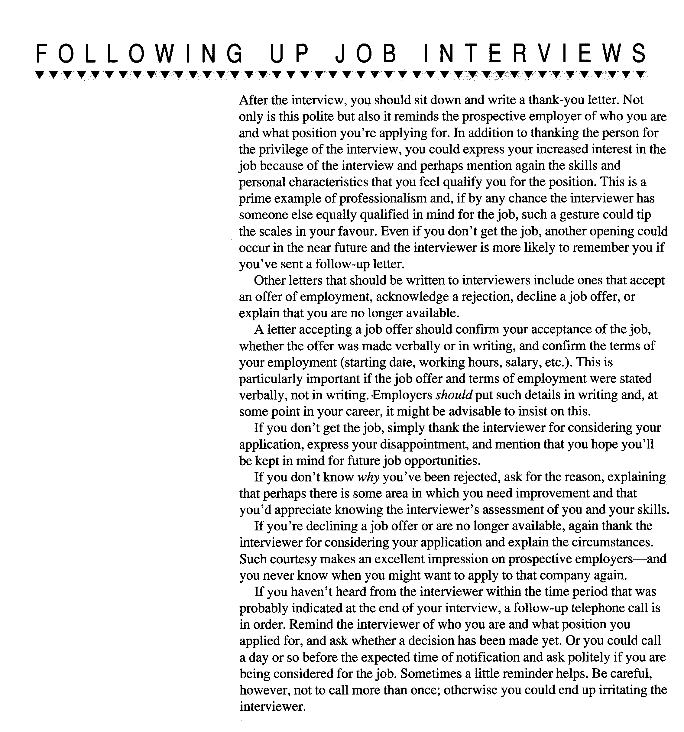
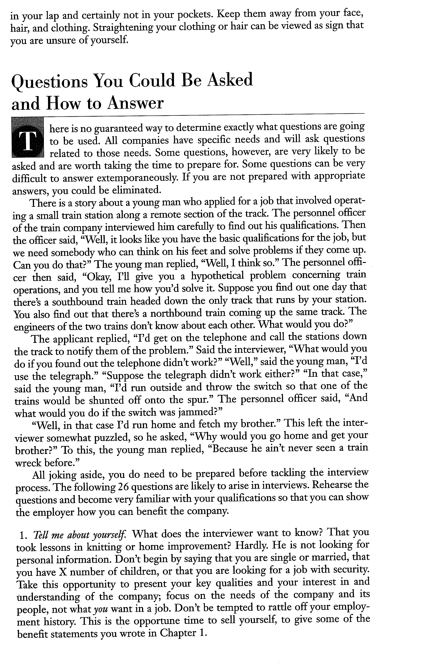
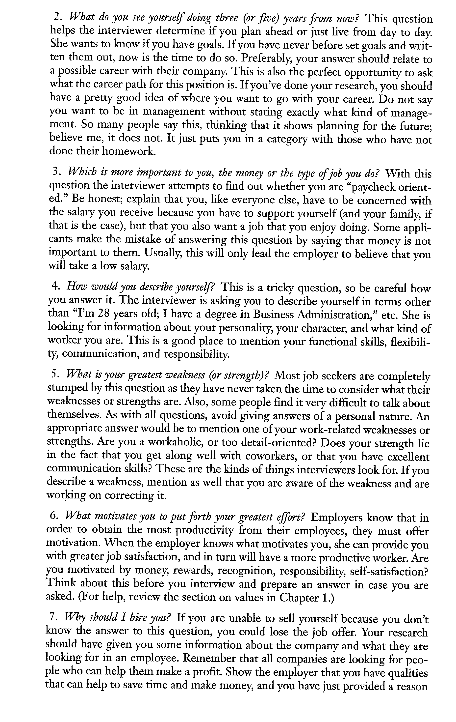
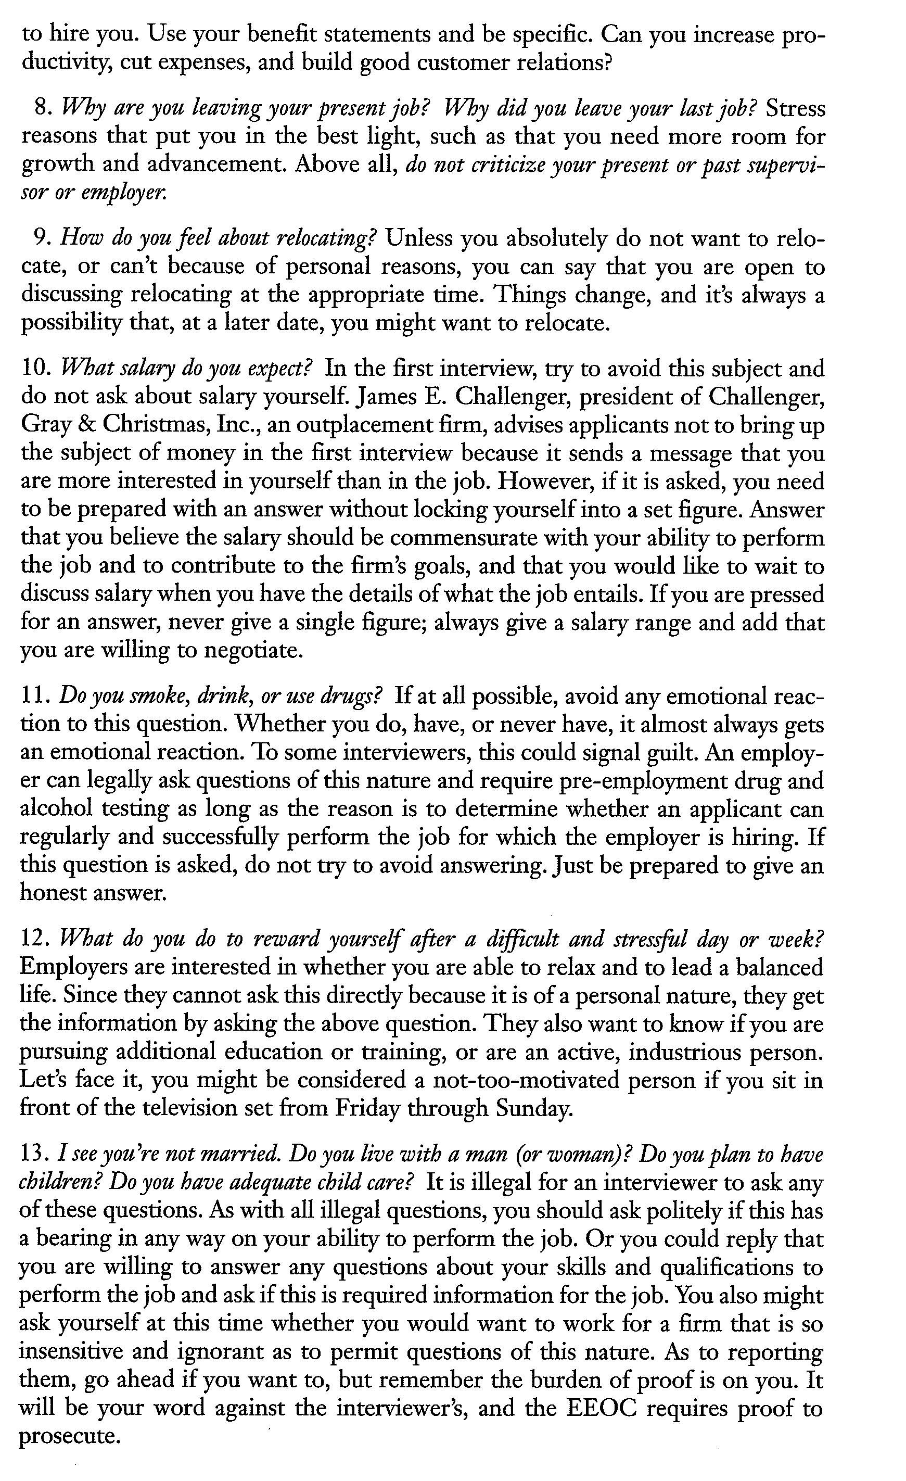
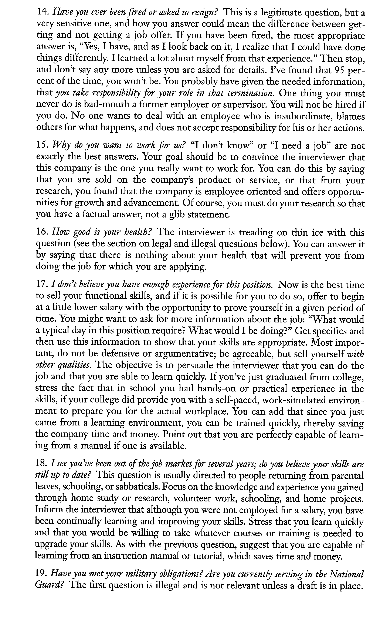
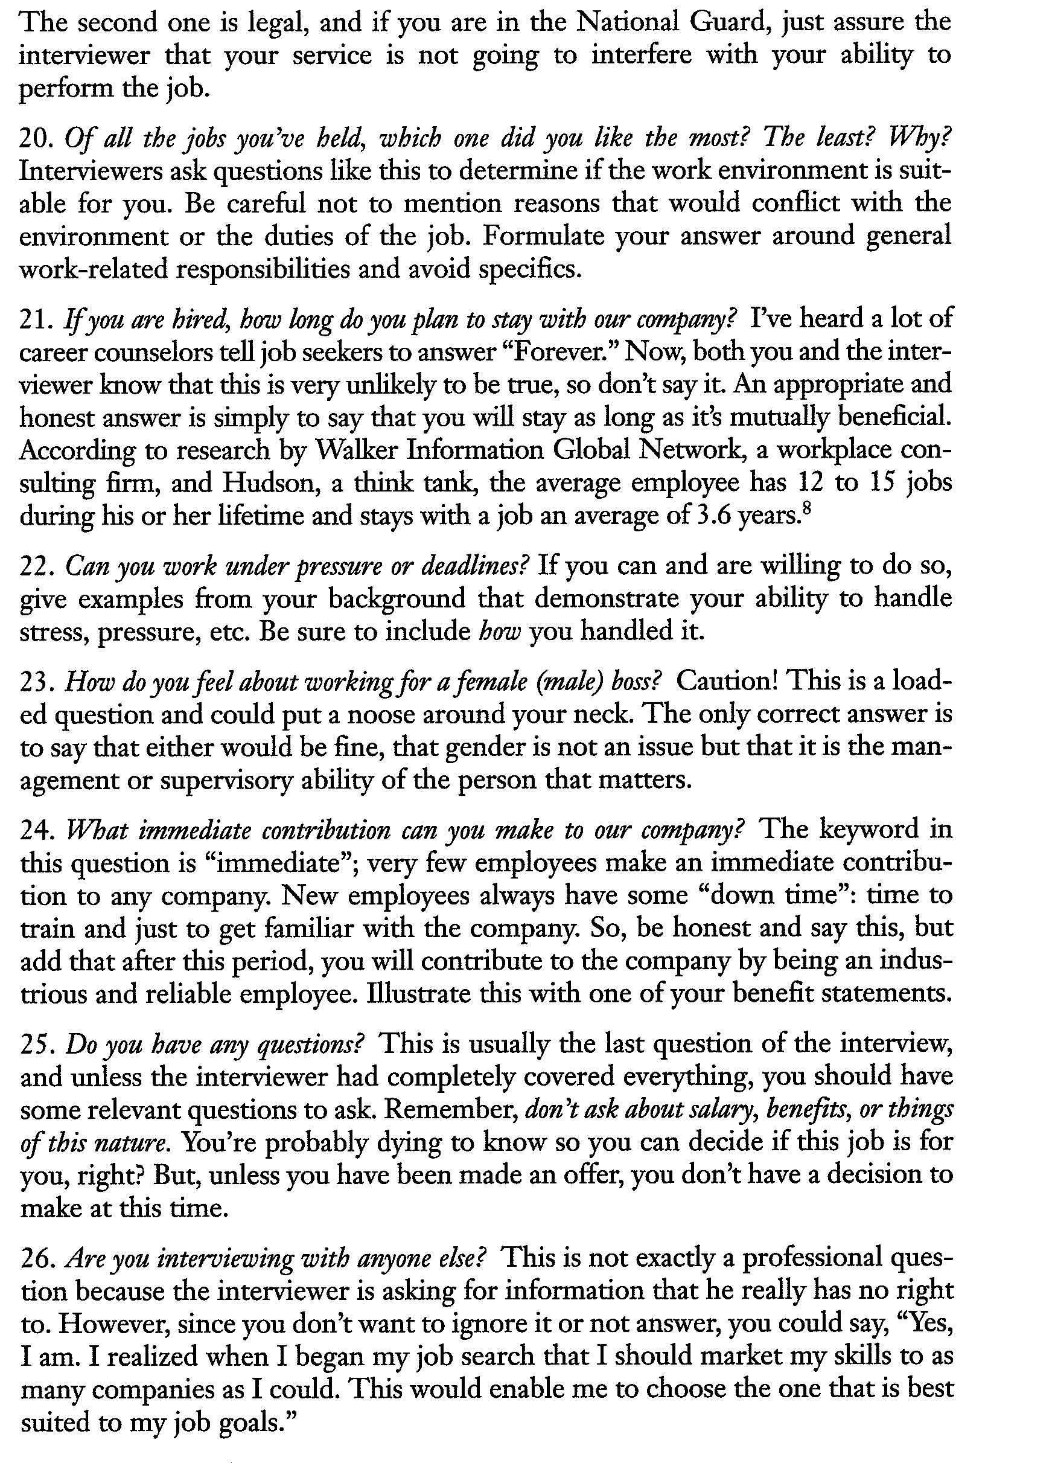
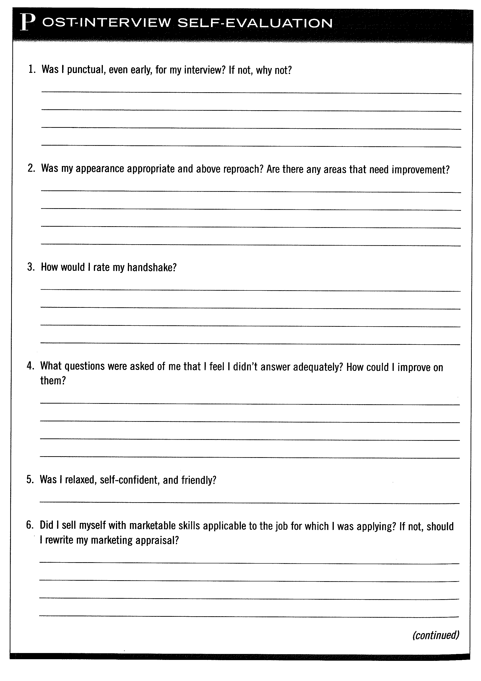
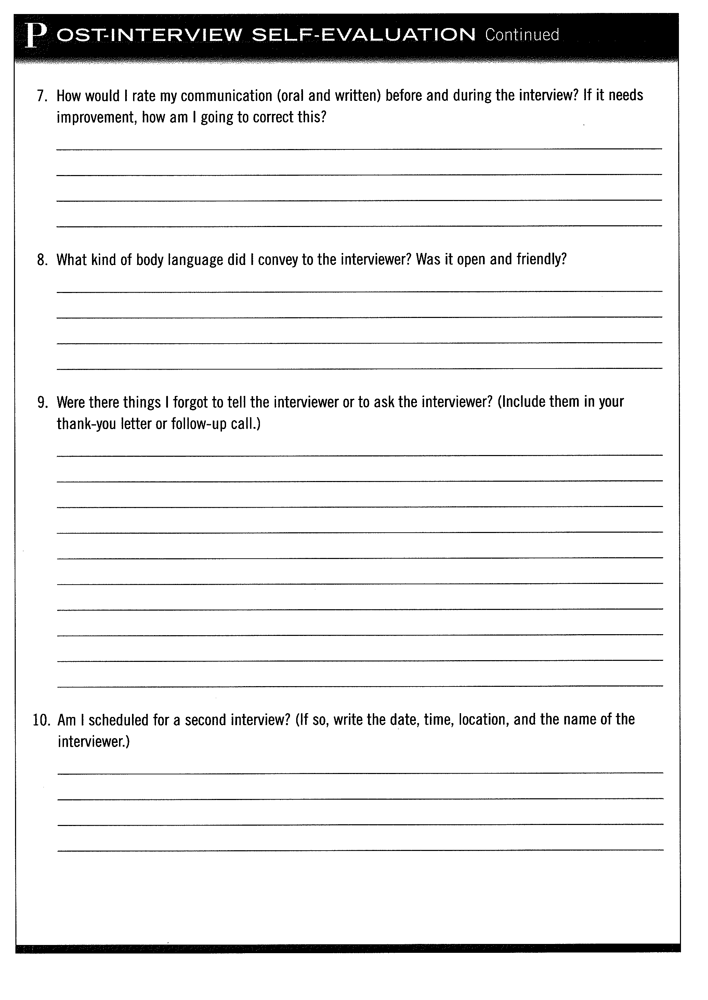
Resource List:

Brand, Margaret and Ann Olney Sparkes. Success in the Workplace: A Student Guide.
Mississauga, ON: Copp Clark Pitman Ltd., 1990.

Robbins, Carolyn R. The Job Searcher’s Handbook
Upper Saddle River, New Jersey: Pearson Education, Inc., 2006.

